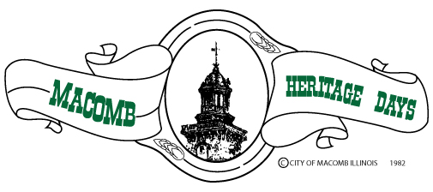

The 2023 Macomb Heritage Days Celebration takes place June 22-24, with the Bob Anstine Memorial parade beginning promptly at 10:00 a.m. on Saturday, June 24th.

This year’s Heritage Days theme is “Saluting Our Institutions of Higher Education.”

The committee invites all local businesses, non-profit organizations, service
clubs and community members to build their own floats and enter the parade. Political organizations are also welcome to participate.

The deadline for Parade entries is noon Friday, June 16th. Late entries will be located at the back of the parade.

For more information, contact the Macomb Area Convention and
Visitors Bureau at 309.833.1315.

2023 Heritage Days Parade Entry Form

Saturday, June 24th — 10:00 a.m.
Parade line-up begins promptly at 9:00a.m. The parade line-up begins at
the intersection of South Johnson and West Washington Streets. Positions
for line-up will be posted on www.makeitmacomb.com and the Heritage
Days Facebook Page by Friday, June 23th.

We want to provide every entry with enough space in the staging area, so
please by VERY SPECIFIC and ACCURATE. Circle all that apply.

Car Wagon Motorcycle/Scooter

Truck Hayrack Boat on Trailer

ATV/Golf Cart Flat Bed Trailer Marching Band

Bicycle Gooseneck Trailer Bus

Walking Group Tractor Horse

Other - Please Describe____________________________________

Total number of vehicles in entry: _________________________________

Approx. number of walkers in unit: ________________________________

—————————————————————————————————

Organization_________________________________________________

Contact Person_______________________________________________

Address_____________________________________________________

Cell number for contact person___________________________________

Email_______________________________________________________
For questions, please call (309) 833-1315,
Monday - Friday 8:30am-4:30pm.

Return this form to:
Macomb Area Convention & Visitors Bureau
120 E. Calhoun St, Macomb, IL

Parade Rules

For the safety of all spectators and each parade participant, any entry with
horses must be accompanied by an adult. NO CANDY CAN BE THROWN
FROM VEHICLES OR FLOATS INTO THE CROWD. Each parade
participant must have walkers to distribute candy to the spectators.
Groups seen throwing candy from vehicles will not be allowed to participate
in the future. In order to create a more positive experience for parade
onlookers, water activities will be limited to the designated water zones
only. This will ensure that participants who are not interested in being wet
will be safe from inclusion. The Heritage Days Committee also reserves the
right to disqualify any entrants deemed inappropriate or offensive. Any
offenders will be excluded from future participation.

Please sign acknowledging all rules and please pass the information on to
all participants.

____________________________
Name (printed)

____________________________
Signature

____________________________
Date

Parade Entry Description
This will be used for the benefit of the live Television Broadcasters. Please
write the name of your entry as you would like it announced and a
description of 25 words or less. Anything over 25 words will be omitted.

Name of Entry________________________________________________

Description (25 words or less)

____________________________________________________________

____________________________________________________________

________________________ _________________________
Name (print) Signature

___________________________________________
Business/Organization

